**Experiment-2**

**AIM OF EXPERIMENT:-**

**Creating, Configuring and Launching cloud compute services**

## Task 1: Launch Your Amazon EC2 Instance

Step 1:

1. In the **AWS Management Console** choose **Services**, choose **Compute** and then choose **EC2**.
2. Choose the Launch instance  menu and select **Launch instance**.
3. Give the instance the name Web Server.
4. In the list of available Quick Start AMIs, keep the default **Amazon Linux** AMI selected.
5. Also keep the default **Amazon Linux 2023 AMI** selected.

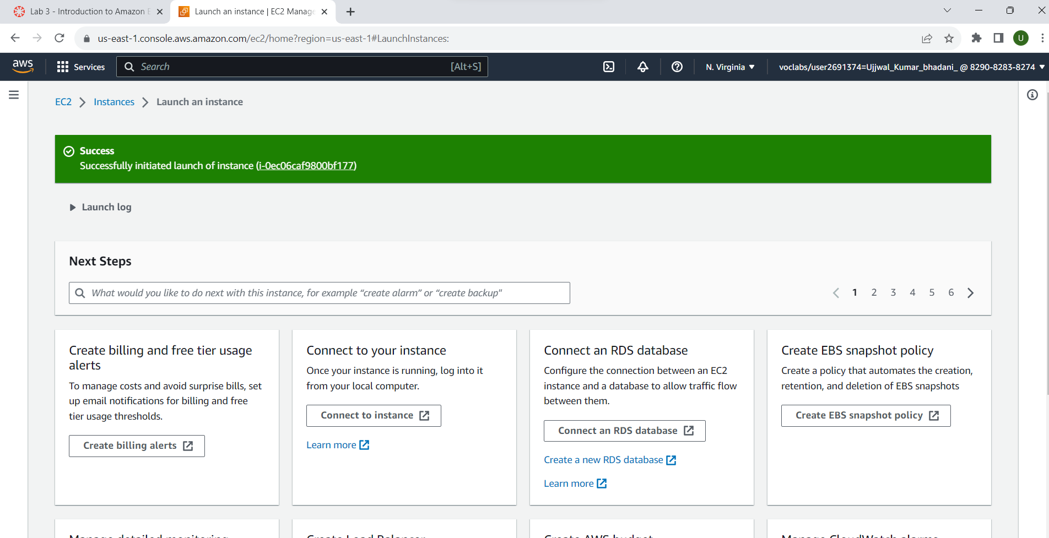

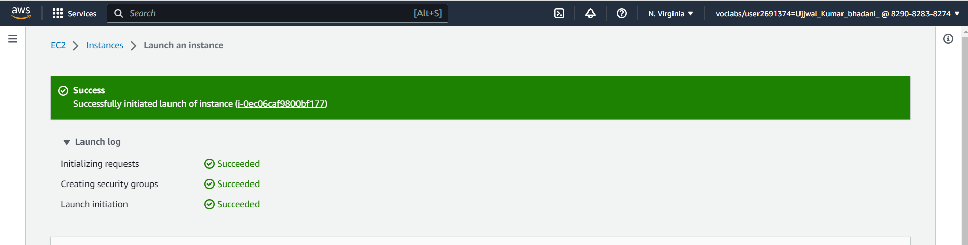

### Step 2: Instance type

1. In the Instance type panel, keep the default **t2.micro** selected.

### Step 3: Key pair (login)

1. For **Key pair name -** required, choose **vockey**.

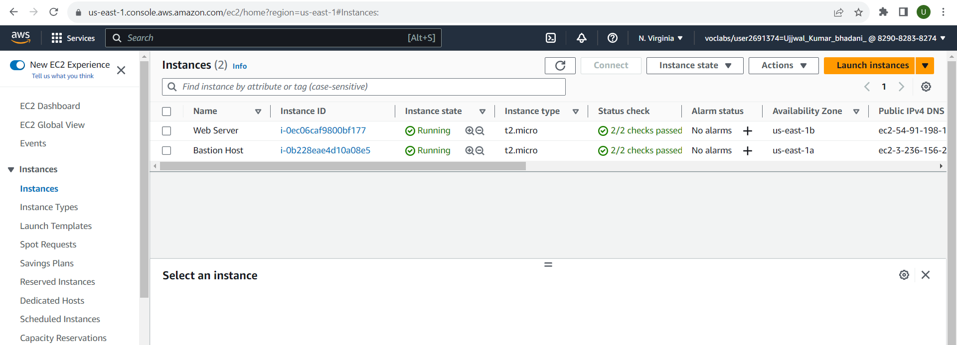

### Step 4: Network settings

1. Next to Network settings, choose **Edit**.
2. For **VPC**, select **Lab VPC**.

Under **Firewall (security groups)**, choose **Create security group** and configure:

1. **Security group name:** Web Server security group
2. **Description:** Security group for my web server

### Step 5: Configure storage

1. In the Configure storage section, keep the default settings.

### Step 6: Advanced details

1. Expand **Advanced details**.
2. For **Termination protection**, select **Enable**
3. Scroll to the bottom of the page and then copy and paste the code shown below into the **User data** box:

### 

### Step 7: Launch the instance

Choose View all instances

1. In the Instances list, select **Web Server**.
2. Review the information displayed in the **Details** tab. It includes information about the instance type, security settings and network settings.
3. Wait for your instance to display the following:
   1. **Instance State:** Running
   2. **Status Checks:** 2/2 checks passed

## Task 2: Monitor Your Instance

1. Choose the **Status checks** tab.
2. Choose the **Monitoring** tab.
3. In the Actions menu towards the top of the console, select **Monitor and troubleshoot** **Get system log**.
4. Scroll through the output and note that the HTTP package was installed from the **user data** that you added when you created the instance.

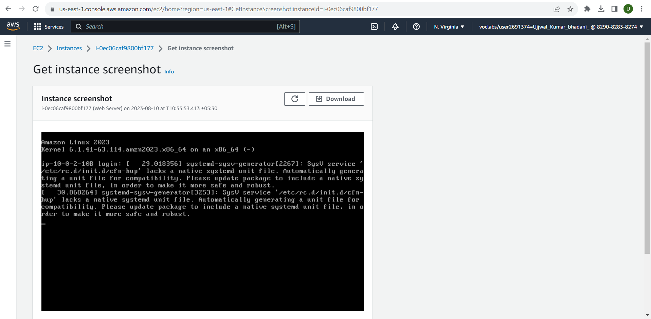

1. Choose **Cancel**.
2. Ensure **Web Server** is still selected. Then, in the Actions menu, select **Monitor and troubleshoot** **Get instance screenshot**

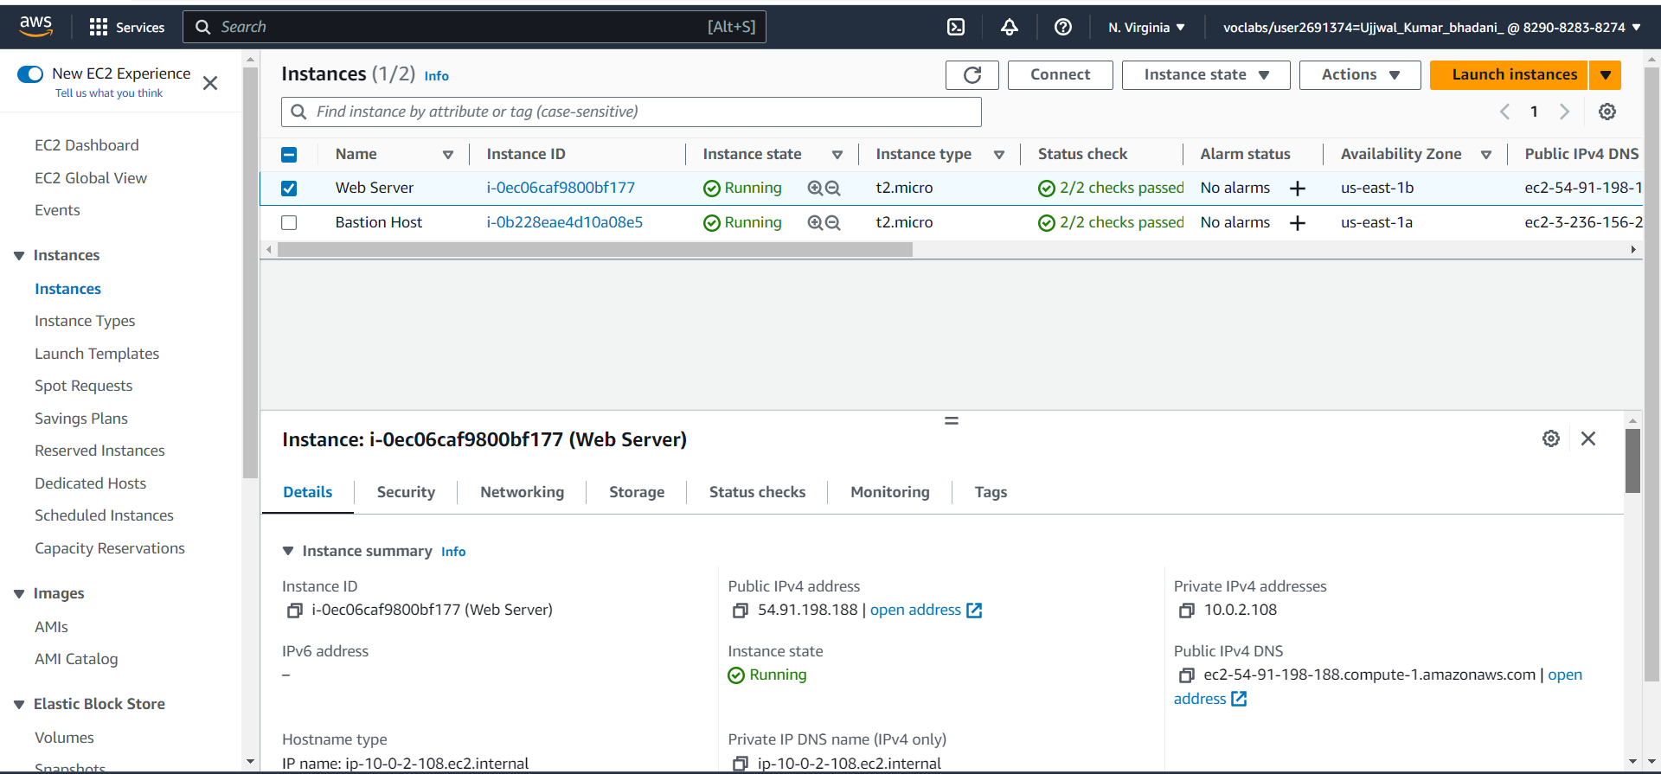

## Task 3: Update Your Security Group and Access the Web Server

1. Ensure **Web Server** is still selected. Choose the **Details** tab.
2. Copy the **Public IPv4 address** of your instance to your clipboard.
3. Open a new tab in your web browser, paste the IP address you just copied, then press Enter.

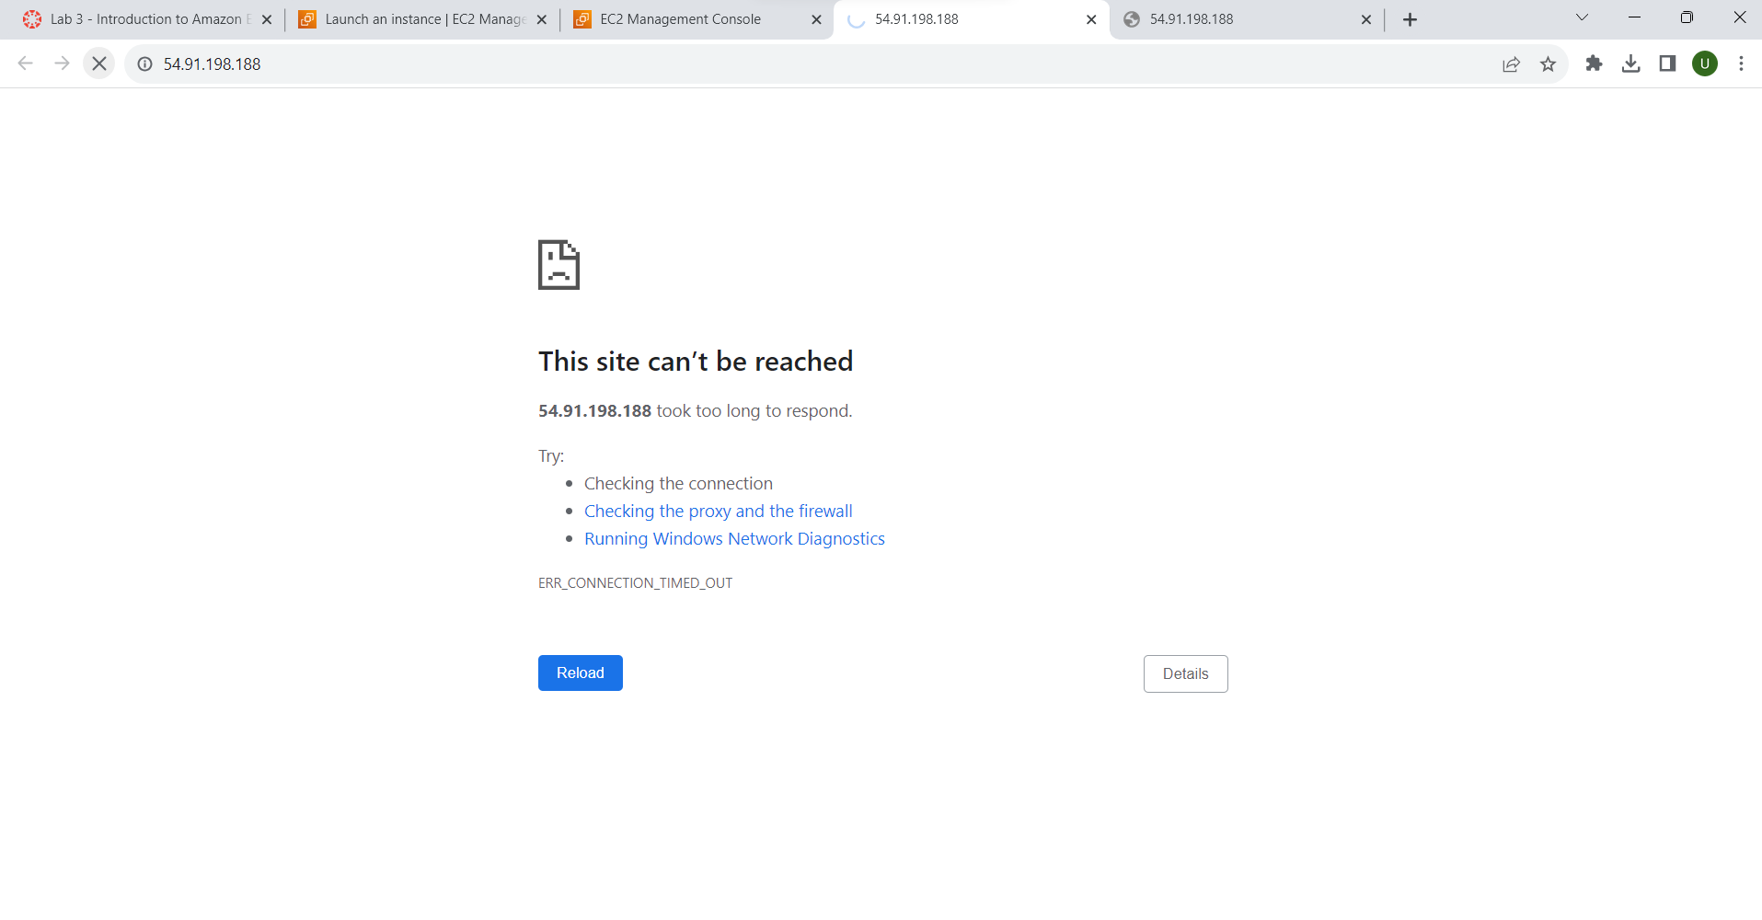

1. Keep the browser tab open, but return to the **EC2 Console** tab.
2. In the left navigation pane, choose **Security Groups**.
3. Select **Web Server security group**.
4. Choose the **Inbound rules** tab.

Choose Edit inbound rules, select Add rule and then configure:

* **Type:** HTTP
* **Source:** Anywhere-IPv4
* Choose Save rules

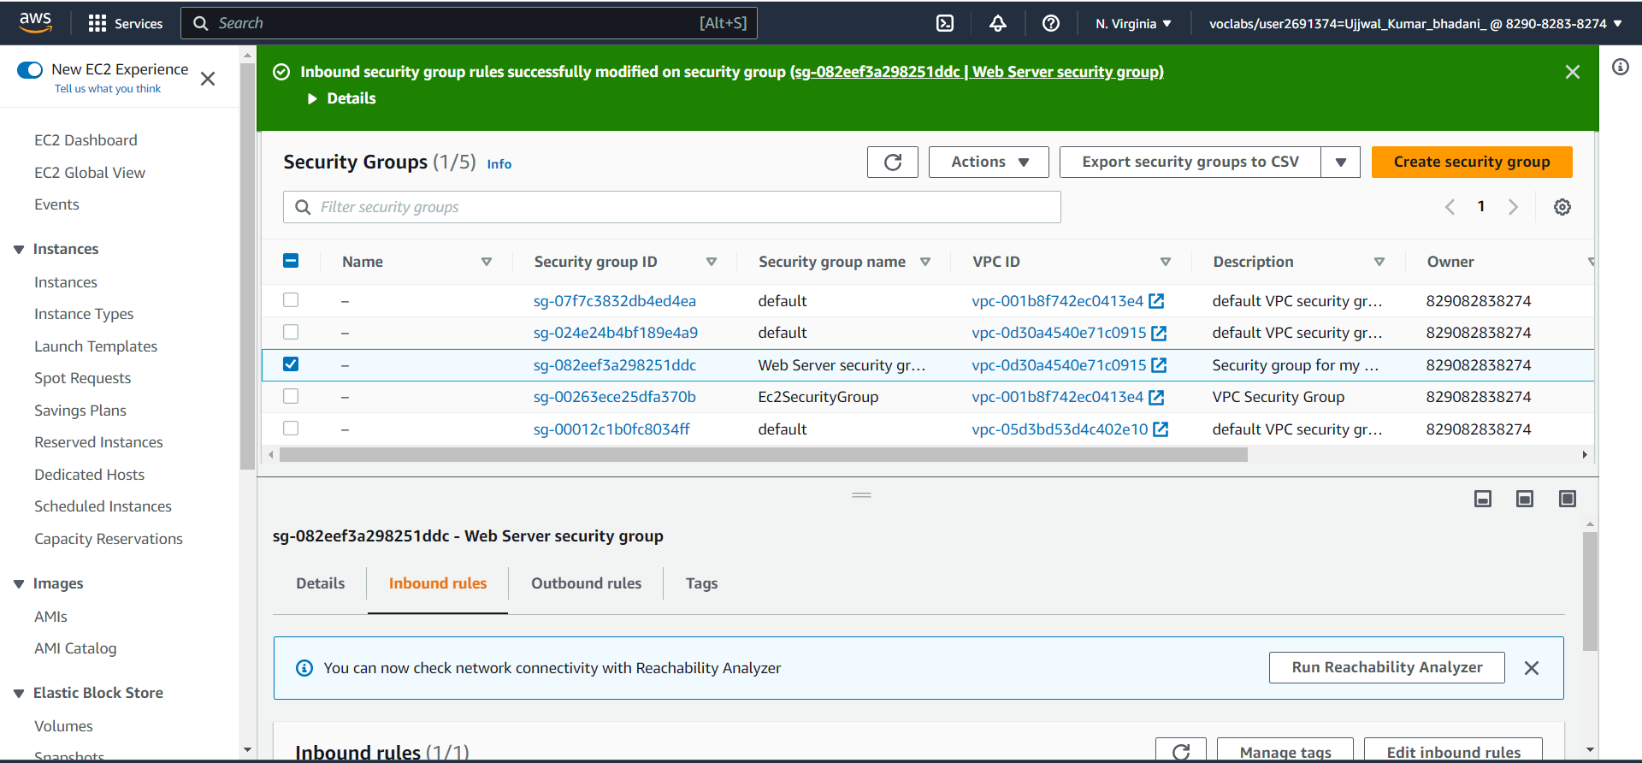

Return to the web server tab that you previously opened and refresh the page.

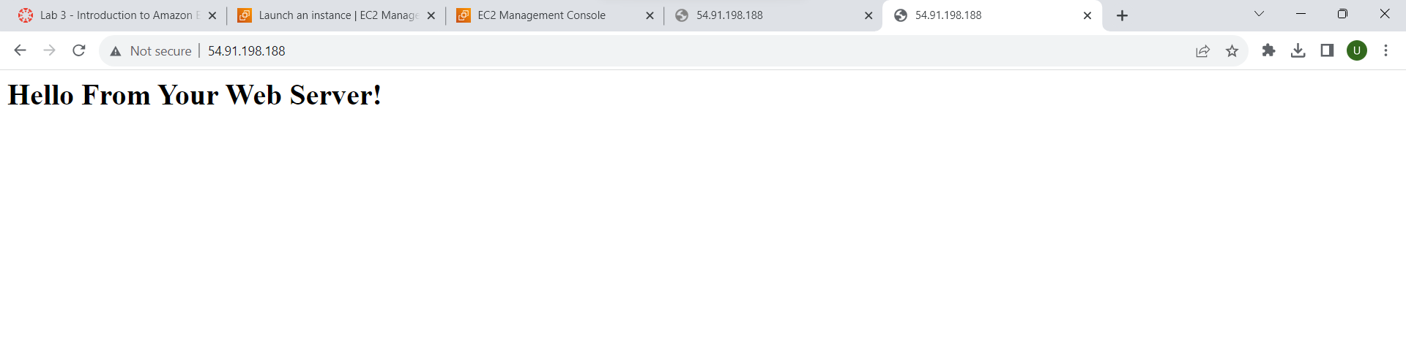

## Task 4: Resize Your Instance: Instance Type and EBS Volume

### Stop Your Instance

1. On the **EC2 Management Console**, in the left navigation pane, choose **Instances**.

* **Web Server** should already be selected.

1. In the Instance State  menu, select **Stop instance**.
2. Choose Stop
3. Wait for the **Instance state** to display: Stopped.
4. In the Actions menu, select **Instance settings** **Change instance type**, then configure:

* **Instance Type:** t2.small
* Choose Apply

### Resize the EBS Volume

1. With the Web Server instance still selected, choose the **Storage** tab, select the name of the Volume ID, then select the checkbox next to the volume that displays.
2. In the Actions menu, select **Modify volume**.

The disk volume currently has a size of 8 GiB. You will now increase the size of this disk.

1. Change the size to: 10 **NOTE**: You may be restricted from creating large Amazon EBS volumes in this lab.
2. Choose Modify
3. Choose Modify again to confirm and increase the size of the volume.

### Start the Resized Instance

1. In left navigation pane, choose **Instances**.
2. Select the **Web Server** instance.
3. In the Instance state menu, select **Start instance**.

**Congratulations!** You have successfully resized your Amazon EC2 Instance.

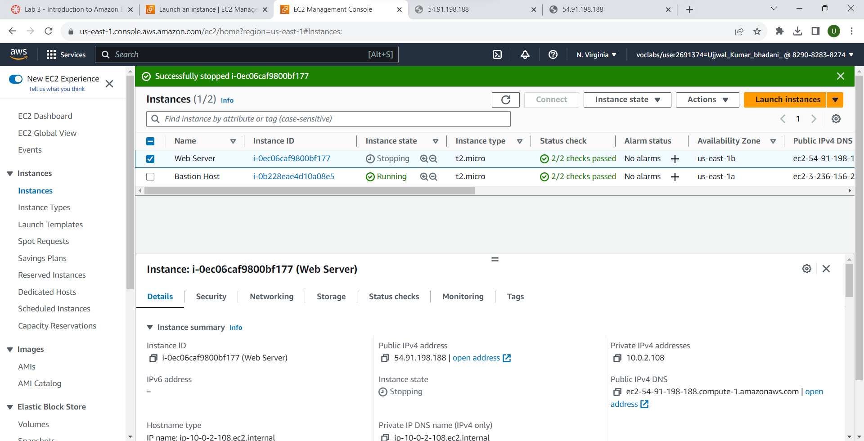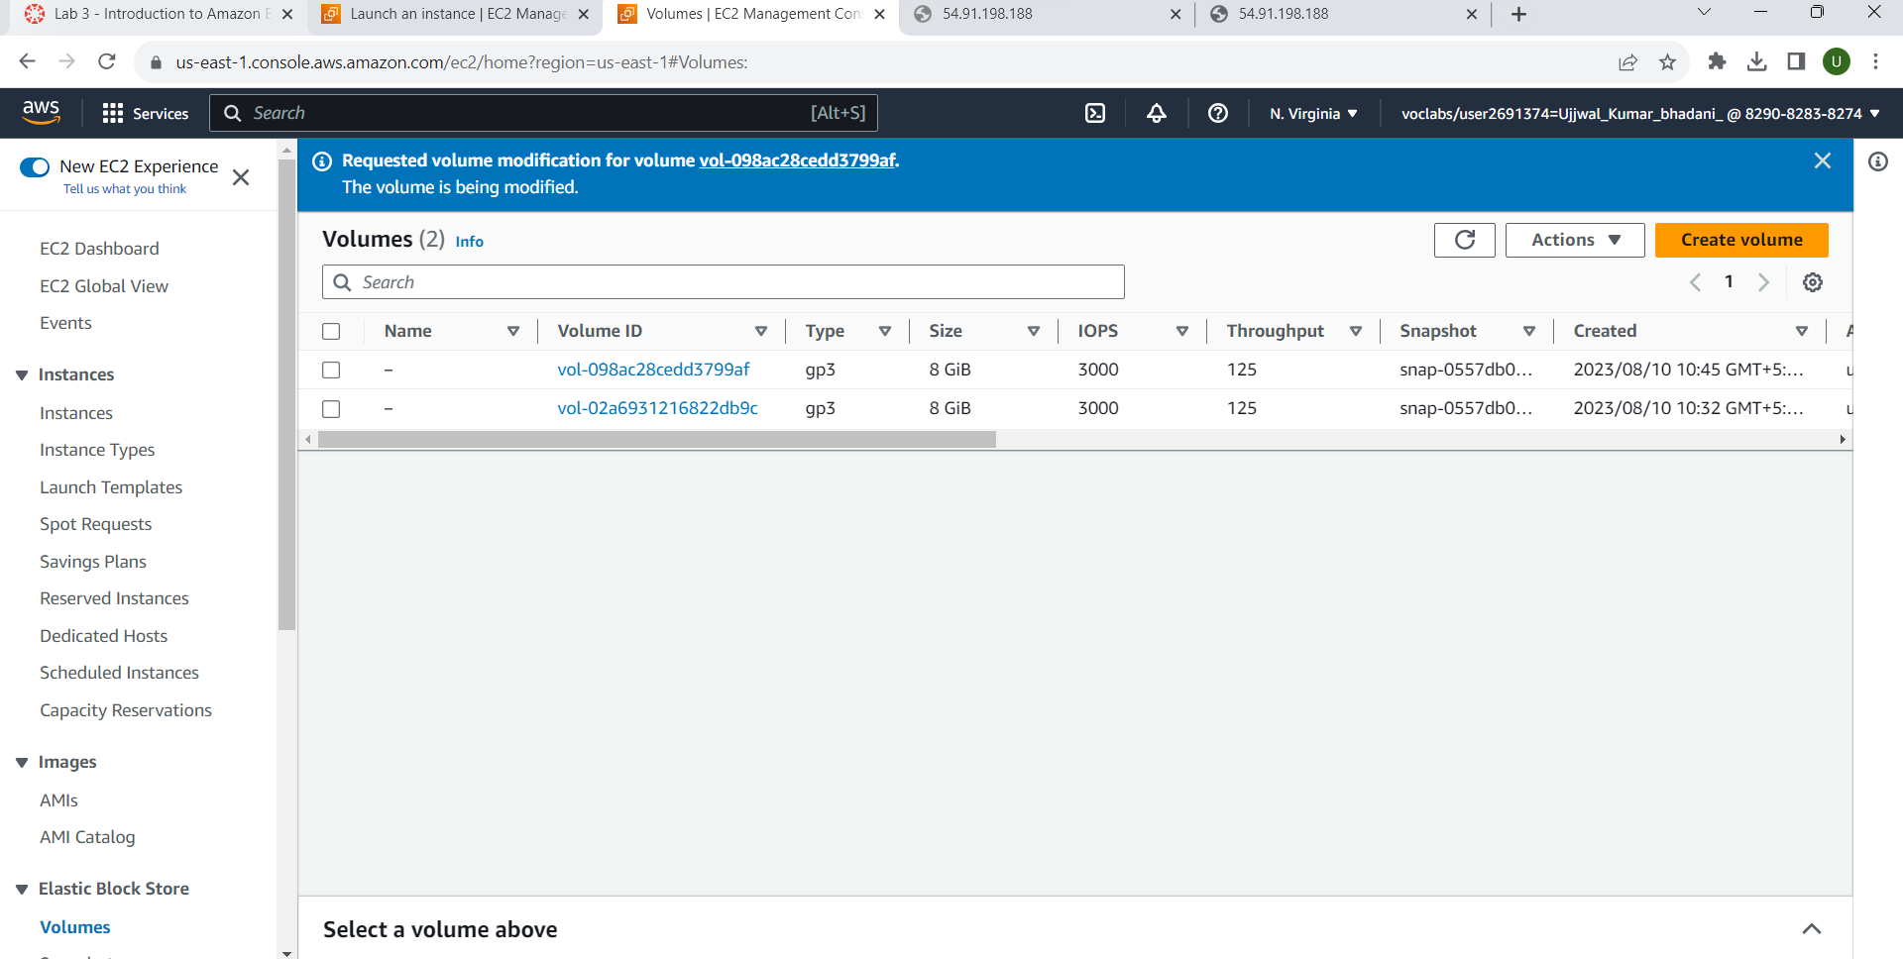

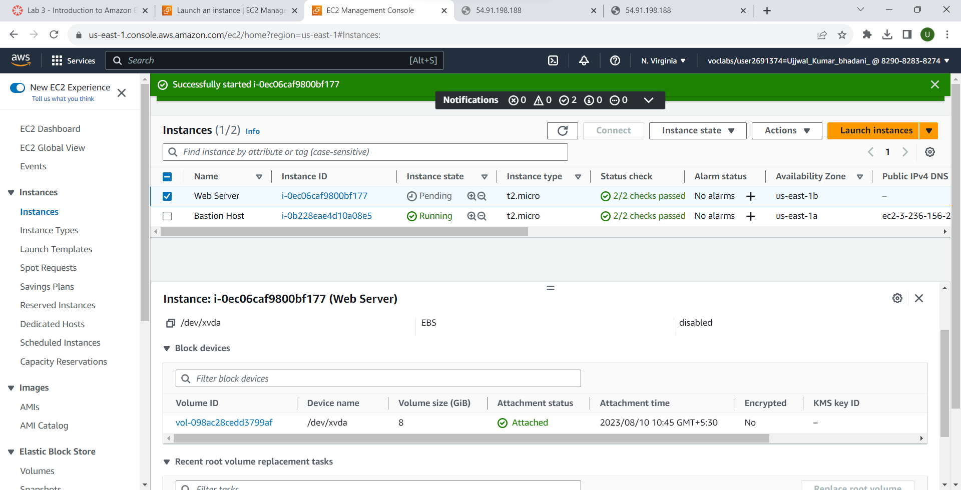

## Task 5: Explore EC2 Limits

1. In the AWS Management Console, in the search box next to **Services**, search for and choose Service Quotas
2. Choose **AWS services** from the navigation menu and then in the AWS services Find services search bar, search for ec2 and choose **Amazon Elastic Compute Cloud (Amazon EC2)**.
3. In the Find quotas search bar, search for running on-demand, but do not make a selection. Instead, observe the filtered list of service quotas that match the criteria.

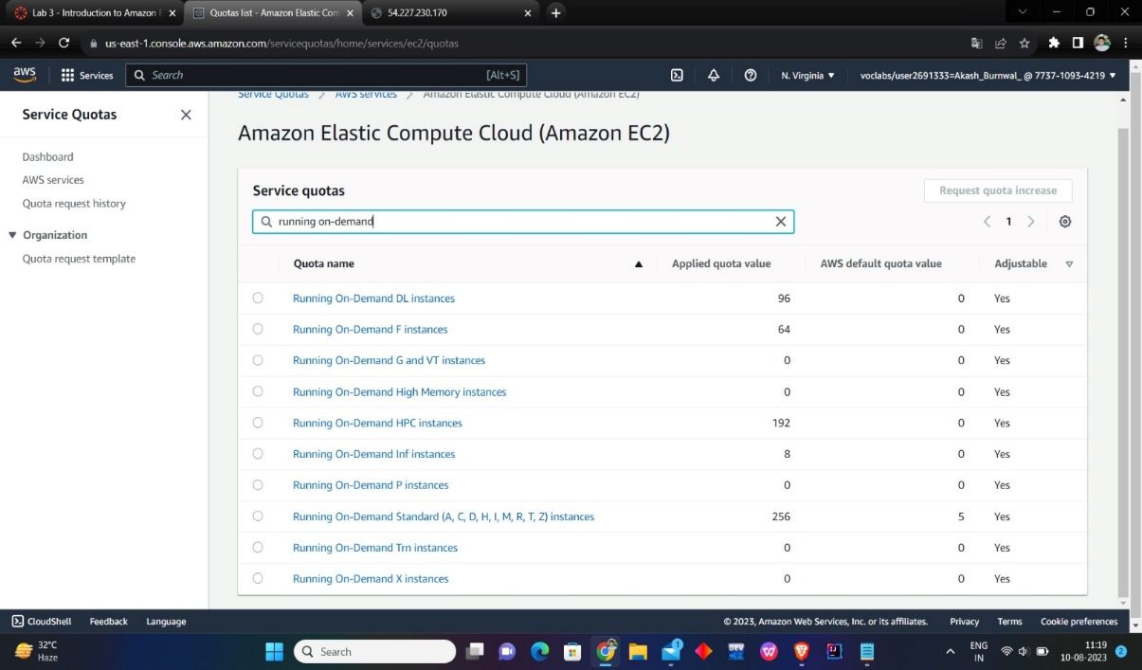

## Task 6: Test Termination Protection

1. In the AWS Management Console, in the search box next to **Services**, search for and choose EC2 to return to the EC2 console.
2. In left navigation pane, choose **Instances**.
3. Select the **Web Server** instance and in the Instance state menu, select **Terminate instance**.
4. Then choose Terminate Note that there is a message that says: Failed to terminate the instance i-1234567xxx. The instance 'i-1234567xxx' may not be terminated. Modify its 'disableApiTermination' instance attribute and try again.
5. In the Actions menu, select **Instance settings** **Change termination protection**.
6. Remove the check next to **Enable.**
7. Choose Save You can now terminate the instance.
8. Select the **Web Server** instance again and in the Instance state menu, select **Terminate instance**.
9. Choose Terminate

**Congratulations!** You have successfully tested termination protection and terminated your instance.

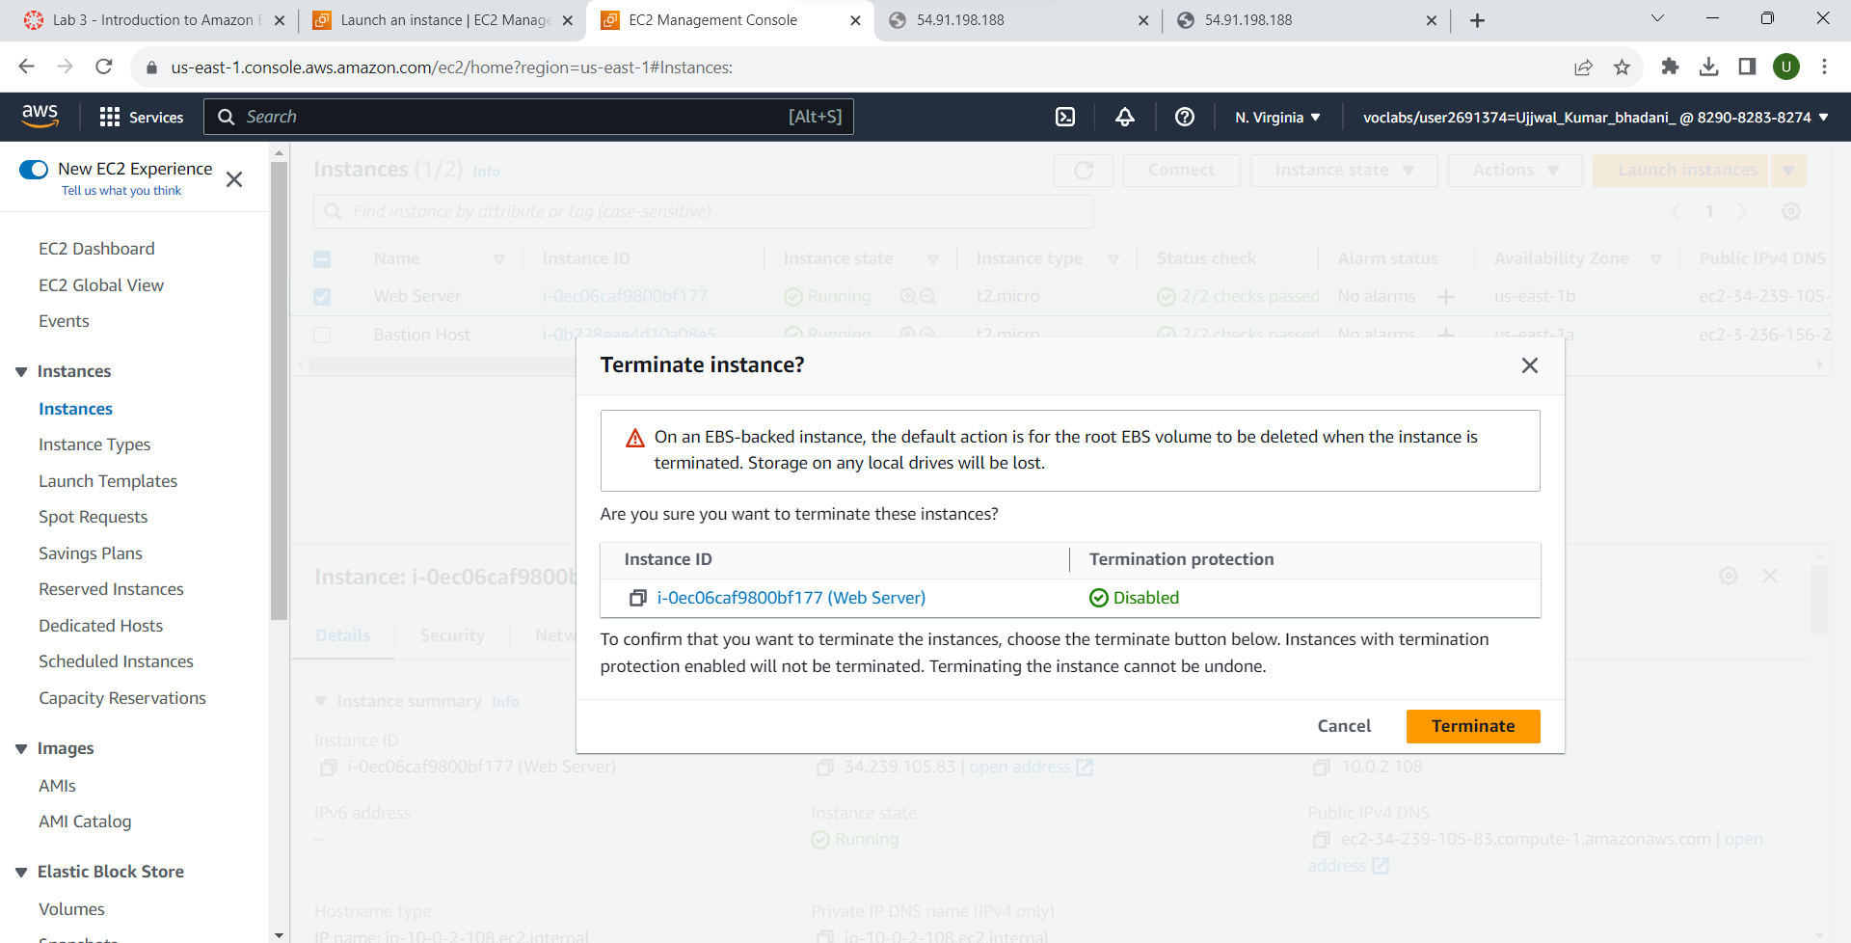

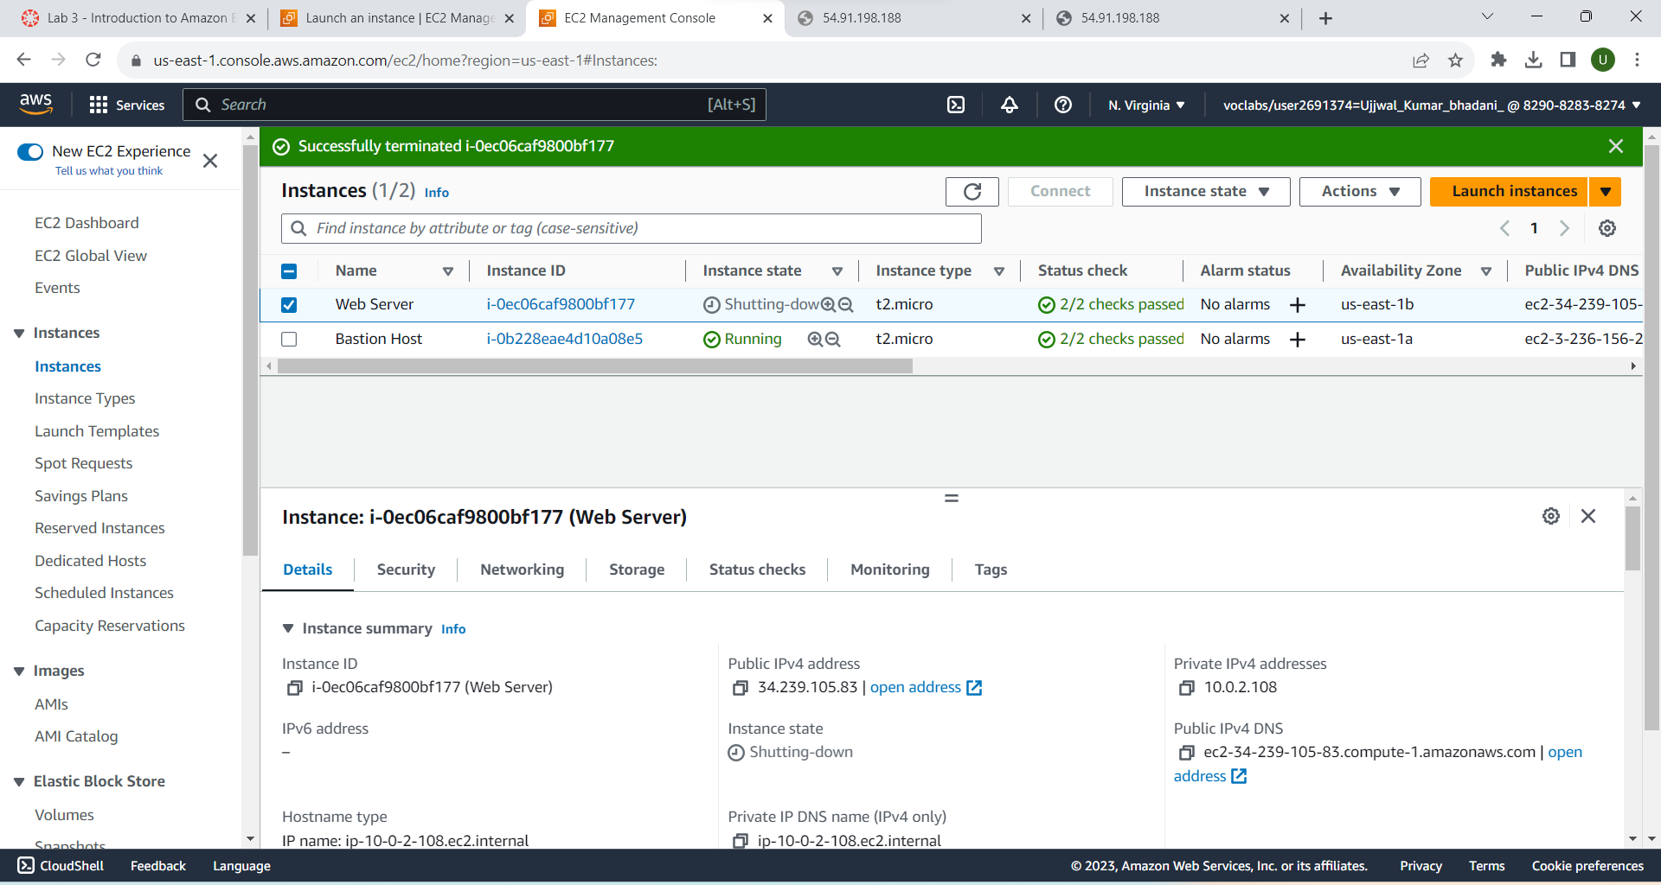

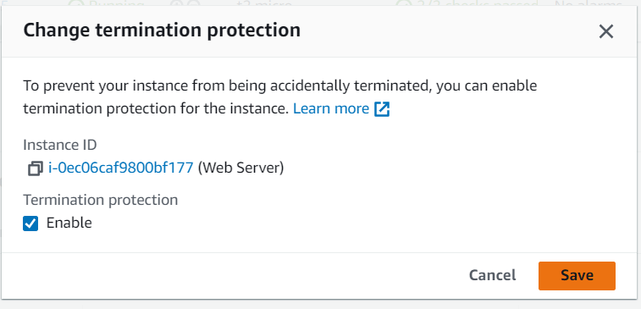

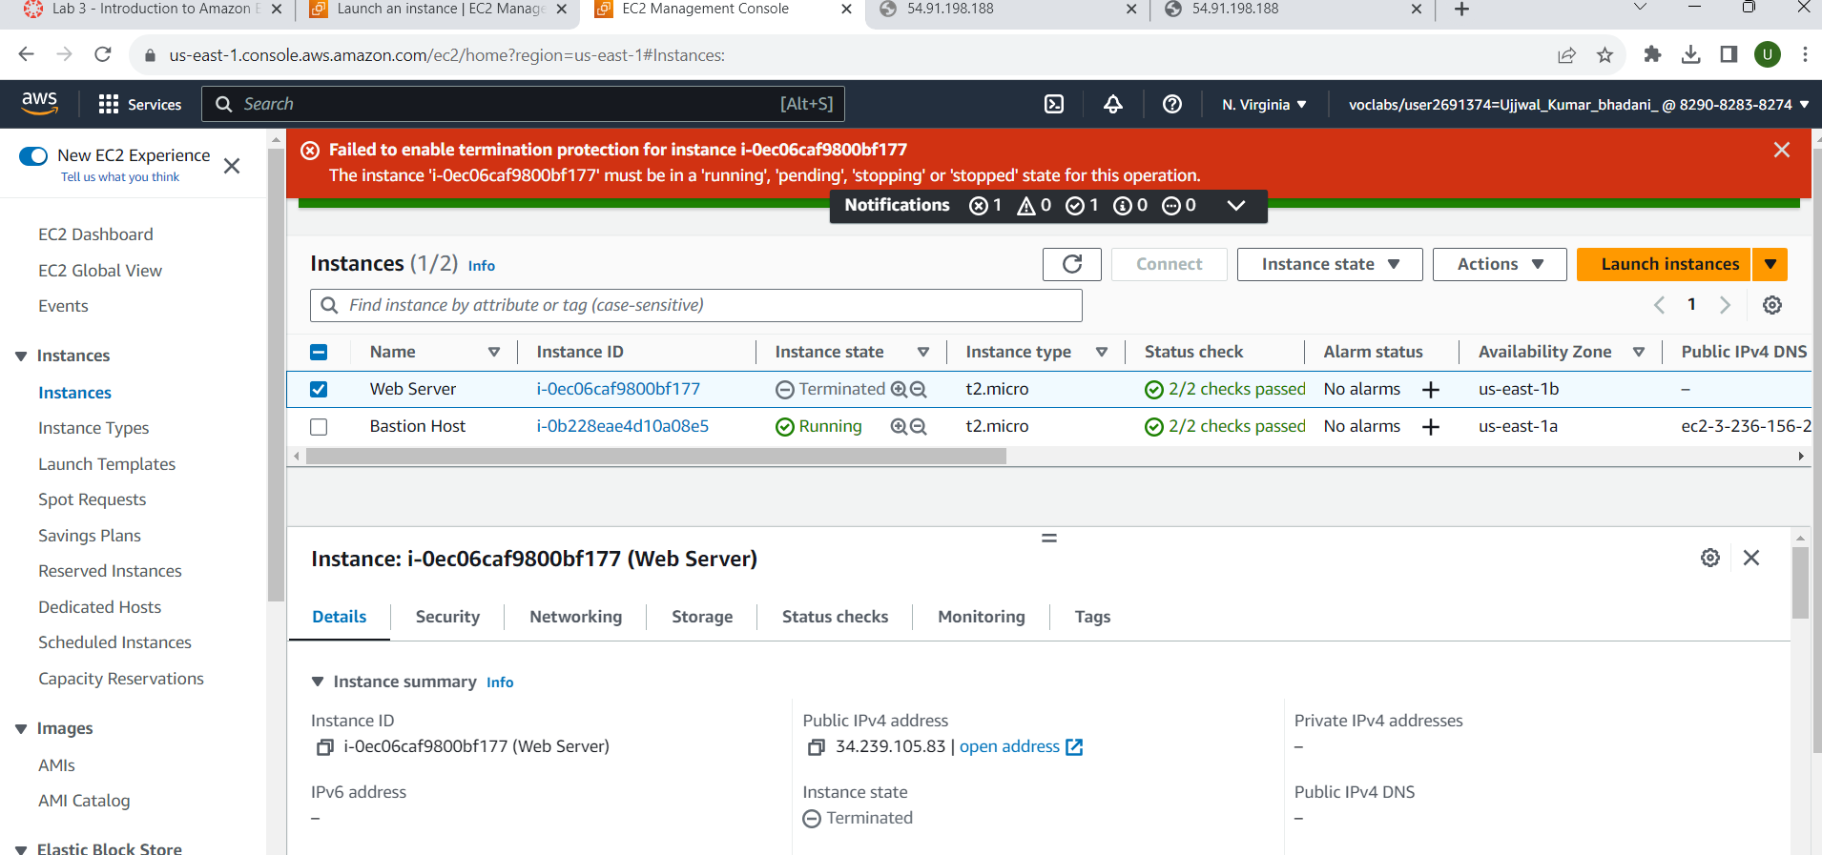

Submitted by

|  |  |
| --- | --- |
| Name | Ujjwal Kumar Bhadani |
| Regd. No | 2101020286 |
| Roll No. | CIT21046 |